“A word fitly spoken is like apples of gold in setting of silver.”
Bob and Mary knocked and the door was opened. Searching for a location to hold their wedding ceremony, they inquired within. They were warmly welcomed by the secretary; the pastor was not in, but they said that they would call. A difference they noted in the welcome here: “Our wedding ceremony was not a business appointment to be scheduled; our marriage was of personal importance.” Mary called, not once but twice before she reached the pastor. Within two days the couple and the pastor had met and arranged additional meetings and the ceremony.
The couple had driven through the intersection of Middlefield and Melville as hundreds, likely thousands, do each day. And they had been looking for a picturesque place for a wedding ceremony, as some do. At other churches the couple had previously stopped and discussed their intent, but they stayed here not because of the garden setting and the appeal of the buildings but because of words fitly spoken to them.
You probably will not be the office secretary greeting visitors at the door or the pastor offering the words of Scripture for the man and woman planning a wedding ceremony and anticipating marriage. Yet the wise person knows the constructive power of good, and in particular, how this is revealed in our speech.
The balance of the proverb is the word fitly. Our speech must fit, be tailored, and measured. Not forced. Not hammered. Instead, appropriate for the situation. The destination of our words, another’s ears and heart, has to be measured by careful listening and reflection, and empowered by an attitude of care and personal regard. A proverb from carpentry would be good here: measure twice, speak once. The right word at the right time is a precious gift to another person in need.
We have to battle our tongues daily. Too often we might blurt things out, and cause everyone at the table to pause and think, “Why did she ever say that?” How often has a tongue been used as a sword, sometimes rusty, sometimes being waved about as if we were panic-stricken or inept soldiers.
Yet before we say it fitly, we must know what to say; and to know what to say, we first must listen. If we want to give someone a gift with our words, we better have our tongues trained and a treasure of good in our hearts. If our tongue is untrained or rusty, how well can you really minister to another’s ears and heart?
How is a tongue trained and our hearts filled with a reservoir of the good? What words must we hear? Words fitly spoken to us. One greater than Solomon has come. In Christ our Lord exists all wisdom, a perfect relationship of fear, love, and trust in the Father and genuinely expressed in His words to people, whether in rebuke of the unrepentant sinner or a word of forgiveness to those who know that only He can revive a broken spirit.
Jesus’ wisdom is proven genuine and indisputable by what He suffered. His wisdom trusted the Father for all—even when people yet today say, “A crucified man saves people from death?! How foolish!” Into the Father’s word fitly said, “You are My Son,” Jesus commended Himself.
The same word was fitly spoken to you at your baptism and still remains on you. The word is also fitly spoken to you at holy communion. Receive into you ear and mouth the forgiveness of sin in Christ’s body and blood. At the time of guilt. At the time of doubt. At the time of need. At the time of separation. At the time of loneliness. At the time of spiritual emptiness. At the time of “Where do I belong?”
What do we say to all of this? It is meet, right, and salutary. A word fitly spoken to God, offering to Him thanks and praise at all times and in all places. Because of all that He has spoken to us, we speak words of praise and honor to Him. The lips cleansed by His word and washed pure by His body and blood are the same lips that will speak to the neighbor. We speak fitly in our daily conversation.
A “fitly spoken word” is not waxing eloquent, buffing an oratorical halo. It is not getting across your idea; it is not being right and proving another wrong; it is not smothering the other with our clever advice. All that is arrogance and pride. And it is not pleasing the hearer—that is plain flattery and maybe deceit.
A fitly spoken word is about the other person. For his well-being, for her life. It is about discernment, recognizing the pain and sorrow, joy and hope, of another. The word rightly spoken might be a penetrating question that compels the other to think and walk around his circumstance, draws her out of her box, challenging preconceptions or lazy thinking. It might be a rebuke, a call to repentance, a word that bruises the heart. And then it will be a word of comfort, forgiveness, and hope. It is of course true, but offered in humility. It might be subtle, as the aroma of a fine wine, giving the hearer an opportunity to ponder and exercise thought on the word fitly spoken.
God has spoken fitly His Word to us; and then by that word He has recreated our tongues to speak to others. To speak fitly we first must have the words; and to have His words on our tongues, we first must His words in our ears. Hear the Lord, as He speaks to us, for then our words will be as golden apples in bowls of silver.

In Christ, Pastor Crown

Vicarage 2008-2009
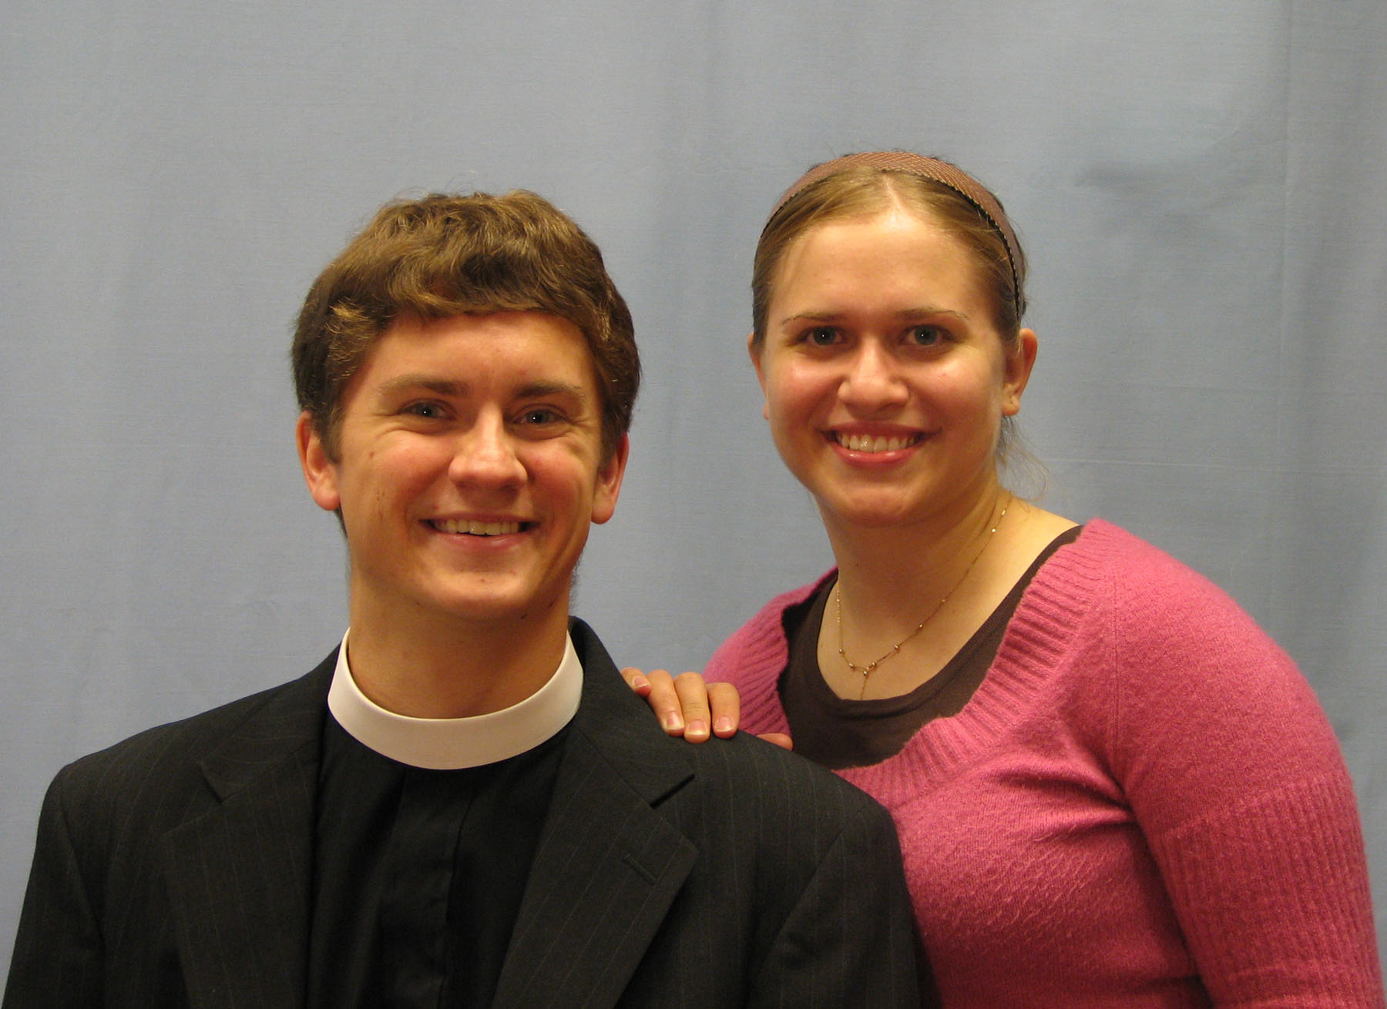
Dear Brothers and Sisters in Christ,
Greetings to you from Concordia Theological Seminary! I am very excited to serve as vicar at Trinity Evangelical Lutheran Church. I learned that you have a long history of the vicarage program. God has been gracious to His church by providing her with congregations like you to equip seminarians who are training for the ministry. I am thankful for the opportunity to serve you.
I am from Bothell, Washington (a suburb of Seattle) and my wife, Lisa, is from Frankenmuth, Michigan. We both graduated from Concordia University River Forest with degrees in music. Lisa currently teaches general music and directs bands at several Lutheran schools in the area. She is looking forward to teaching at Grace Lutheran School in San Mateo. Keep me in your prayers as I finish this academic year. I pray that God may strengthen and preserve you in His Word.
In Christ, Seminarian David Solum

The Body of Christ at Trinity
Tony Brown has been given a release. We thank the Lord of the Church that He provided Tony both the will and the strength to serve as assistant treasurer for several years.
Diane Nesom (nee Weikal) and her daughter Katrina and son Anthony have transferred their membership to Shepherd of the Valley, San Jose.
Edward Paul Krajewski (d. May 12, 2008) was born on June 2, 1908, in Detroit, Michigan, to Charles and Frieda (neé Striewski) Krajewski, the first of nine siblings. He was baptized at Zion Lutheran Church, and attended the grade school there. He dropped out of school in the 11th grade to help in the family grocery store during his father’s illness. Ed and Gertrude Daniels (d. 10/2000) were married on October 6, 1934. The union produced five children: Donald, Robert, Roy, Janice (deceased in infancy), and Alice. Always mechanically inclined, he worked in a number of defense factories during the Second World War, and, in spite of a lack of formal education, became an automotive interior designer at the Styling Center of General Motors. Retired in 1973, the family moved to Sunnyvale, California in 1975. If there is a dominant theme to his life, it would be devoted service to the several churches he was a member of. At Trinity he served as deacon, trustee and usher. Constantly alert to nonfunctioning hardware or a need to improve something, he also witnessed his faith during mission and evangelism calls. He truly loved to serve. Until the day of the resurrection, his mortal remains are interred next to his wife of 66 years in Livonia, Michigan.

Graduates 2008
Naoya Nishino, having completed his entrance examinations, is attending Kansai Medical College in Moriguchi, Japan, a suburb of Osaka.
Nellie Olsen will graduate from Stanford University with a B.S. in Geological and Environmental Sciences this June. “The past four years have flown by, however I do find myself knowing shortcuts around campus and, while I am doing a problem sets, realizing that I would not have had any clue how to do the problems three years ago. My studies at Stanford have focused on geochemistry or how elements move around at the earth’s surface and in the earth’s interior. Next year I will be pursuing a coterminal master’s degree at Stanford studying the geochemistry of arsenic in geothermal systems.”
Katherine Stalder just graduated with a Masters degree in Computational and Mathematical Engineering. “I will be looking into many career options, but primarily at bioengineering and renewable energy/green engineering positions.”
Roseanne Warren will be doing a one-year master’s degree in mechanical engineering, and looks forward to another year with the members of Trinity and Lutheran Student Fellowship.
Mark Aochi will be graduated from Archbishop Mitty (San Jose); he will attend San Diego State University, to complete a major in mechanical engineering; he will also take part in ROTC and intends to serve as jet mechanic in the Navy after graduation.
Tim Crown will be graduated from Palo Alto High School; he will attend Concordia University-Irvine, and his emphasis will be in history and sports management / business.

Movie Review: “Expelled: No Intelligence Allowed”

Donn Parker
“EXPELLED: No Intelligence Allowed” is a documentary movie being shown in movie theaters. Lorna and I saw it at the Saratoga AMC at an outrageous ticket price even for seniors. I conclude that it is biased propaganda masquerading as a factual documentary on the order of several recent biased Michael Moore documentaries and simply provides fodder for atheists and their cause by demonstrating some of the dumb things that are done in the support of religion. I recommend the New York Times’ very negative review of the movie rather than my trying to analyze it any more than to say the following. The movie starts by assuming that the audience knows what intelligent design and Darwinism are. The current positions on intelligent design, evolution, and creationism are all about defending one or the other explanation of the development of life on earth. The movie goes far-a-field into the Holocaust, Berlin wall, and fascism that have nothing to do with intelligent design or evolution except as examples of people not acting very intelligently. Its claims that teachers and researchers have been unjustly fired because of promoting intelligent design are problematic. Other reasons for the firings are ignored. The movie tells about the dispute among scientists between intelligent design and evolution (Science says that intelligent design is not a valid scientific theory since it can’t be proven.) and then muddies the water by inserting religious beliefs. Believing something that is not subject to proof and scientific conjecture that is subject to proof (such as scientific theories of evolution) are two different concepts that differentiate religion and science. I believe that God is omnipotent and intelligently created all life; Christians believe in what Genesis reveals about creation—although what it says leaves us with great mysteries and questions as do intelligent design and evolution in both religious and scientific frameworks. Genesis is amazing in explaining the beginning of the universe and life that has made sense to both ancient and modern people that believe in the Word of God.

Death with Dignity or Death with Promise?
The Rev. John Pless, Assistant Professor of Pastoral Theology and Missions
Concordia Theological Seminary, Fort Wayne.
This article, from Thy Kingdom Come, a publication of CTS-FW, has been reprinted with permission.
“Originally death was not part of his (man’s) nature. He dies because he provoked God’s wrath. Death is, in his case, the inevitable and deserved consequence of his sin and disobedience,” writes Dr. Martin Luther (American Edition 13:94). Luther states the biblical truth (Genesis 3:19; Psalm 90; I Samuel 2:6; and Romans 5:12-17). Death is the result of sin. it is God Himself who executes the death sentence. There is no dignity in death.
Contrast this with the way that death is often pictured today. Death is seen as part and parcel of the grand scheme of things. Our culture perpetuates the lie that death is natural, nothing more than an inevitable and unavoidable turn in the cycle of life. Death is also seen as arbitrary and accidental, something that, perhaps, can be permanently overcome or at least temporarily delayed by improved efforts in public safety, self-care, and medical technology. We do the best we can to manage death. We desire a death with dignity. If death cannot be avoided, we will at least engineer the time and the place. We will take our own life before it can be ripped from us. It is called euthanasia and suicide.
Yet for all its attempts to naturalize death, to deny its linkage to our sin and God’s wrath, and to beckon death to conform its arrival to our timing, our age retains some recognition that death is about a judgment,. It is evidence of Oswald Beyer’s assertion that the universe is forensically structured, always demanding justification. Listen to the eulogies delivered at funeral rites for unbelievers. They attempt to justify, that, is, they render a judgment that the life of the deceased was worthy something because he was a devoted husband and loving father, a successful business man or a skilled mechanic, an active member of the Rotary Club or Republican Party, and the list goes on. Is it not strange that those who would deny the existence of God feel themselves compelled t justify life in the face of death?
Christians alone are finally able to see death for what it is: God’s own termination of sin. God’s Law speaks and carries out a death sentence. It is not simply that human beings are mortal and are therefore deprived of life. Then the cure would be immortality. Rather, human beings are sinners who must die. The answer to death is not to be found in engineering a way around death or through death to the so-called other side but by hearing a word of absolution that announces and bestows the forgiveness of sins. Where there is forgiveness of sins, death is robbed of its terror. Death swallowed up by the death of Jesus on the cross now becomes the portal to life everlasting. By Jesus’ death, the last enemy is disarmed, for where the forgiveness of sins reigns, thee is life and salvation. Embedded in the absolution is the promise of the resurrection.
Pastors come to the dying to speak that word. It is a word that unmasks our culture’s myths concerning death and dying. It enlivens dying sinners to dine in ease, for the death that really counts, Jesus’ death for sin and our death to sin, has already happened. It is not about death with dignity but death with promise!

50 Years for Our Savior’s Lutheran Church, Pacifica
You are cordially invited to our joyous 50th anniversary celebrating the dedication of the church building of Our Savior’s Lutheran Church on Sunday, June 22, 2008; the service will be held at 4:00 p.m. A dinner follows. RSVP to Lori Fisher (650) 359-3280 by June 8, 2008.

The Board of Elders’ Visitation: Goals and Means
To guide their God-given service in the congregation the Board of Elders and Pastor Crown have created a plan for the regular visitation of Trinity members. The visits have three specific goals; the Elders and Pastor seek:
  - To nurture the reconciliation that the Body of Christ receives through the Word and Sacraments.
(Psalm 133:1; Matthew 18:21; Matthew 18:35: Romans 12:18; Ephesians 4:25; Ephesians 4:32; Ephesians 5:21; Philippians 4:2)
  - To encourage regular attendance of the services of the congregation, in order to:
- Partake of the fellowship of the preached Word;
- Partake of the fellowship of the Holy Communion; and
- Be encouraged by the presence and confession of other Christians.
(Joshua 24:22-24; Psalm 1:2-3; Isaiah 55:11; Acts 2:42; I Corinthians 11:26; I Thessalonians 2:13; Hebrews 10:25; I Peter 1:23)
  - To encourage a godly and robust stewardship in time, talent, and treasure, in order to:
    - Support each other in times of need;
    - Rejoice with each other in times of happiness;
    - Create a godly environment for Christians and families;
    - Know the others in order to pray for them; and
    - Encourage them in specific ways for their daily vocations.
(Mark 3:35; Acts 2:45; Romans 12:10; Romans 12:13; Romans 12:15; Romans 14:19; Romans 15:1; Galatians 6:2; Hebrews 10:24; Hebrews 13:16; Hebrews 13:18)
This first of our ongoing visitations incorporates aspects of all three goals. We intend to introduce the Lutheran Service Book for family use and show how in-home use supports congregational life.
By familiarizing ourselves with what this hymnal has to offer we desire to build a structure for the Word in the family through a means that the congregation herself uses, and to develop a greater knowledge of the hymnal at home to reaffirm its use in the congregation. We also will provide a personal copy of Lutheran Service Book for each family if so desired.
During 2008 a member of the Board of Elders or Pastor Crown will contact you in order to set a time for the visit. If you have questions or comments, do not hesitate to ask the Elders and Pastor.

Representing the faith in print at Stanford
This year Stanford dedicated a new center for religious activity on the 3rd floor of the Old Union, called the Center for Inter-Religious Community, Learning and Experiences. Our LSF group uses this space for our Sunday night meetings and finds it to be well-used by students in general. One of the features of this space is a reading room containing theological works donated by all the various religions represented on campus, for use by students and on-campus religious workers. Vicar Sias, representing "Evangelical and Conservative Protestants," used $200 of Stanford's money to start a good collection centered on justification by faith.
Trinity now has the opportunity to create a solid "Lutheran presence" in this collection. Pastor, Vicar, and Professor John Pless of Concordia Theological Seminary, Fort Wayne, have compiled a "wish list" for the library. (Vicar can provide a copy of the list, if you'd like to peruse it.) Concordia Publishing House has generously offered us a 40% discount on any CPH materials Trinity would donate to Stanford's collection.
The Board of Campus Ministry therefore invites members of the congregation to donate to this effort. We plan to place an order on August 1 for materials from the "wish list," as funds received allow. Please mark contributions to this effort "Campus Ministry: CIRCLE Library." Thank you for helping represent the faith in print at Stanford!

